* 45203
* One stop drop for hard to recycle items at Earth Day
* Drop Off Sites
  + <https://www.cincinnati-oh.gov/recycling/rumpke-drop-off-sites/>
* Recycling and yard waste are collected every-other-week

What You Can Recycle

* The Cincinnati Recycling Program accepts the following materials:
  + All plastic bottles and jugs, regardless of the number stamped in the bottom. If you crush the jug/bottle, you can screw the lid back on for recycling. Labels ok.
    - NOTE: To be considered a bottle or a jug, the mouth (top) of the container must be smaller than the bottom
  + Glass jars and bottles (any color) – Metal lids ok if detached from bottle, labels ok
  + Aluminum beverage cans
    - Steel cans – Labels may be left on
  + Cartons (Juice boxes, soup/stock boxes, etc.) – remove caps and straws
  + Empty aerosol cans - with lids and tips removed
  + Paperboard (cereal boxes, frozen food boxes, 12-pack containers, etc.)
  + Cardboard - broken down to 3'-by-3' sections
  + A variety of paper products
    - Office paper
    - Newspaper
    - Magazines
    - Junk mail and envelopes (with or without windows)
    - Telephone books
    - Paper grocery bags
    - Clean pizza boxes

**Recycling Centers**

* Batteries
* Plastic bags
* Aluminum pie plates and food containers
* Aluminum cat food cans
* Plastic tubs- butter and yogurt containers, storage containers
* Berry containers (clam shells)
* Any plastic that is not in the shape of a bottle/jug
* Christmas lights
* Light bulbs
* Yard waste or food
* Electronics
* Polystyrene foam
* Hazardous waste
* Window glass, mirrors, drinking glasses
* Bound books
* Picnic ware- plastic cups and silverware, plates, napkins, etc

Should It Be In A Garbage Bag?

**Place your recyclable items in the cart or bi**n. The only exception is shredded paper, which may be placed in a clear plastic bag.

Plastic Grocery Bags

Plastic bags are not accepted in the City’s curbside recycling program. Due to stringent standards for the reselling of this material, manufacturers require plastic bags be clean, dry and in like-new condition to be used in the manufacturing process. Due to the collection and separation process, Rumpke Recycling can’t meet those manufacturer’s standards.

Many local retailers have established plastic bag recycling programs. We encourage you to seek out these types of opportunities to recycle your plastic bags and films. Click [here](https://www.plasticfilmrecycling.org/recycling-bags-and-wraps/find-drop-off-location/) to find an outlet in your area.

* [DOWNLOAD FLIER](https://www.cincinnati-oh.gov/recycling/assets/File/What%20Goes%20In%20The%20Green%20Cart%20.jpeg)

[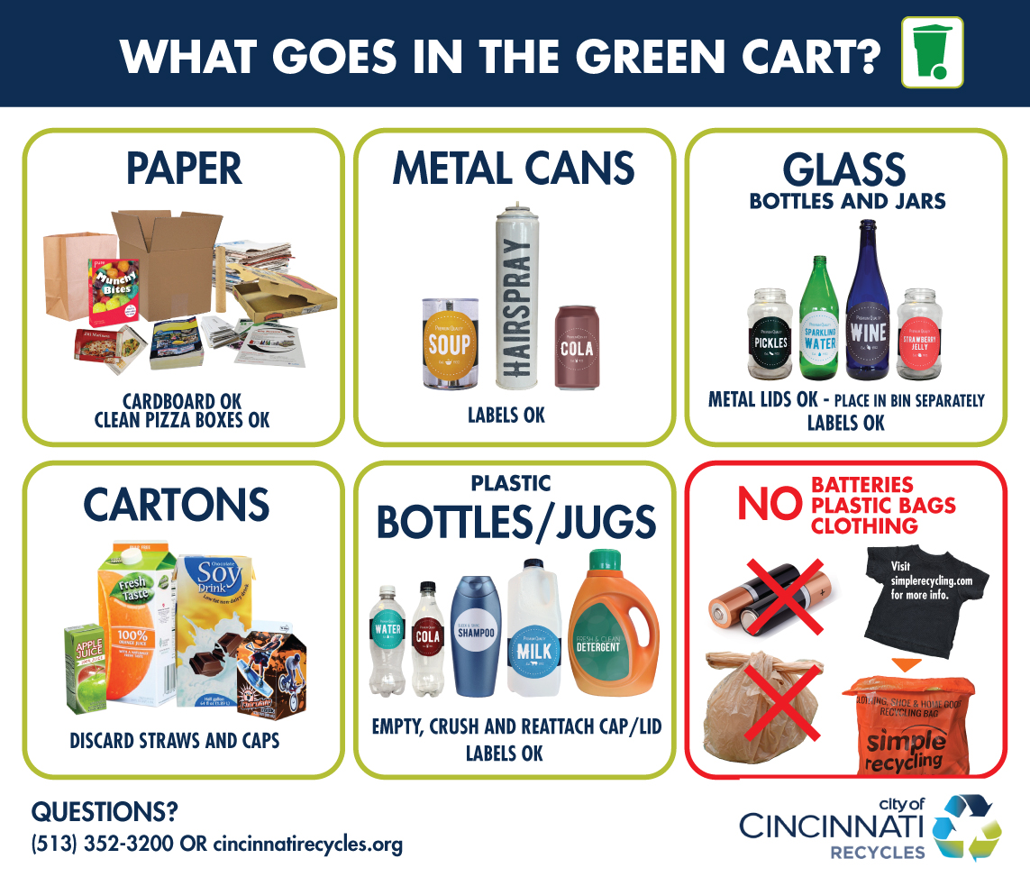](https://www.cincinnati-oh.gov/recycling/assets/File/What%20Goes%20In%20The%20Green%20Cart%20.jpeg)

**Area**